HW 7.3: Tie it together
- Test the hypothesis that sex and smoking habits are dependent at the α = 0.05 level.
Hypotheses:
H₀: Sex and smoking habits are independent
H_{a}: Sex and Smoking habits are dependent
Assumptions:
- The following assumptions are verified: the data are enumerated, placed in mutually exclusive cells and the observations are independent of each other. This is shown in the contingency table below.


- Let’s check the expected count assumption

The dependence test between Sex and Smoking habits passes the expected count assumption.
We can therefore safely interpret our chi-square test and we choose the significance level α=0.05
Code:
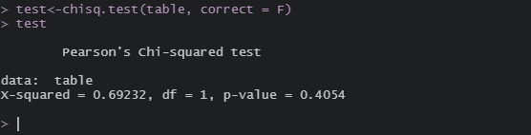
Conclude and interpretation
With an α of 0.05 and p-value of 0.4054, we fail to reject the null and state that we have insufficient evidence to prove that sex and smoking habits are dependent.

- Test the hypothesis that smoking habits and caffeine habits are dependent at the α = 0.10 level.
Hypotheses:
H₀: smoking habits and caffeine habits are independent.
H_{a}: smoking habits and caffeine habits are dependent.
Assumptions:
- The following assumptions are verified: the data are enumerated, placed in mutually exclusive cells and the observations are independent of each other. This is shown in the contingency table below.


- Let’s check the expected count assumption

The dependence test between smoking habits and caffeine habits passes the expected count assumption.
We can therefore safely interpret our chi-square test and we choose the significance level α=0.10
Code:
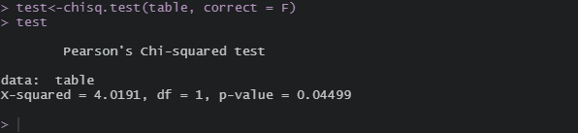
Conclude and interpretation:
With an α of 0.10 and p-value of 0.04499, we reject the null and state that we have sufficient evidence to support that smoking habits and caffeine habits are dependent.

- Test the hypothesis that major and smoking habits are dependent at the α = 0.07 level.
Hypotheses:
H₀: major and smoking habits are independent.
H_{a}: major and smoking habits are dependent.
Assumptions:
- The following assumptions are verified: the data are enumerated, placed in mutually exclusive cells and the observations are independent of each other. This is shown in the contingency table below.
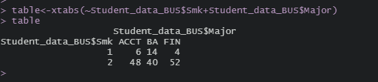

- Let’s check the expected count assumption

The dependence test between major and smoking habits passes the expected count assumption.
We can therefore safely interpret our chi-square test and we choose the significance level α=0.07.
Code:
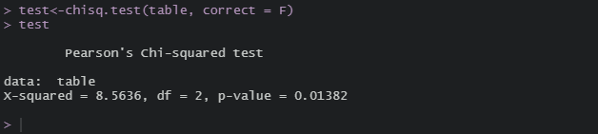
Conclude and interpretation:
With an α of 0.07 and p-value of 0.01382, we reject the null and state that we have sufficient evidence to support that major and smoking habits are dependent.

- Test the hypothesis that sex and major are dependent at the α = 0.01 level.
Hypotheses:
H₀: sex and major are independent.
H_{a}: sex and major are dependent.
Assumptions:
- The following assumptions are verified: the data are enumerated, placed in mutually exclusive cells and the observations are independent of each other. This is shown in the contingency table below.
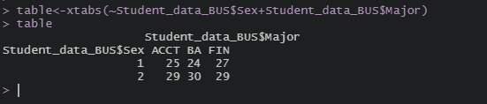

- Let’s check the expected count assumption

The dependence test between sex and major passes the expected count assumption.
We can therefore safely interpret our chi-square test and we choose the significance level α=0.01.
Code:
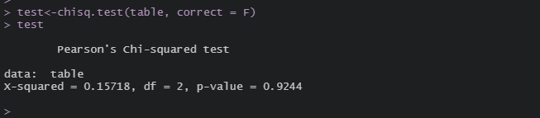
Conclude and interpretation:
With an α of 0.01 and p-value of 0.9244, we fail to reject the null and state we have insufficient evidence to prove that sex and major are dependent.

- Test the hypothesis that aerobic and caffeine habits are dependent at the α = 0.13 level
Hypotheses:
H₀: aerobic and caffeine habits are independent.
H_{a}: aerobic and caffeine habits are dependent.
Assumptions:
- The following assumptions are verified: the data are enumerated, placed in mutually exclusive cells and the observations are independent of each other. This is shown in the contingency table below.
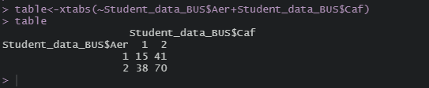

- Let’s check the expected count assumption

The dependence test between aerobic and caffeine habits passes the expected count assumption.
We can therefore safely interpret our chi-square test and we choose the significance level α=0.13.
Code:
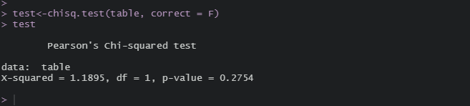
Conclude and interpretation:
With an α of 0.13 and p-value of 0.2754, we fail to reject the null and state that we have insufficient evidence to prove that aerobic and caffeine habits are dependent.

